**Mason Shepherd**

**Homework 10**

R-14.11 [10 points] Would you use the adjacency matrix structure or the adjacency list structure in each of the following cases? Justify your choice.

* 1. The graph has 10,000 vertices and 20,000 edges, and it is important to use as little space as possible.

Ans:

* 1. The graph has 10,000 vertices and 20,000,000 edges, and it is important to use as little space as possible.

Ans:

* 1. You need to answer the query getEdge(*u*, *v*) as fast as possible, no matter how much space you use.

Ans:

R-14.16 [10 points] Let *G* be an undirected graph whose vertices are the integers 1 through 8, and let the adjacent vertices of each vertex be given by the table below:

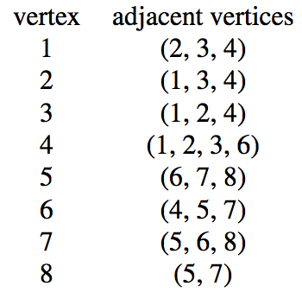

Assume that, in a traversal of *G*, the adjacent vertices of a given vertex are returned in the same order as they are listed in the table above.

1. Draw *G*.

Ans:

1. Give the sequence of vertices of *G* visited using a DFS traversal starting at vertex 1.

Ans:

1. Give the sequence of vertices visited using a BFS traversal starting at vertex 1.

Ans:

R-14.17 [10 points] Bob loves foreign languages and wants to plan his course schedule for the following years. He is interested in the following nine language courses: LA15, LA16, LA22, LA31, LA32, LA126, LA127, LA141, and LA169. The course prerequisites are:

• LA15: (none)

• LA16: LA15

• LA22: (none)

• LA31: LA15

• LA32: LA16, LA31

• LA126: LA22, LA32

• LA127: LA16

• LA141: LA22, LA16

• LA169: LA32

In what order can Bob take these courses, respecting the prerequisites?

Ans:

R-14.20 [10 points] If the vertices of the graph from Figure 14.11 are ordered as (JFK, LAZ, MIA, BOS, ORD, SFO, DFW), in what order would edges be added to the transitive closure during the Floyd-Warshall algorithm?

Ans:

R-14.27 [10 points] There are eight small islands in a lake, and the state wants to build seven bridges to connect them so that each island can be reached from any other one via one or more bridges. The cost of constructing a bridge is proportional to its length. The distances between pairs of islands are given in the following table.

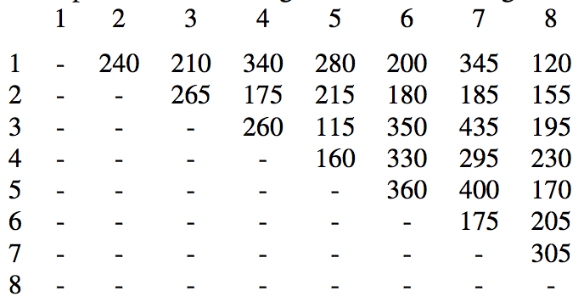

Find which bridges to build to minimize the total construction cost.

Ans:

**Use the graph provided below to answer the following 3 questions.**

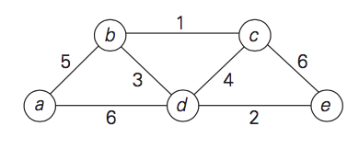

R-14.23 [10 points] Use the graph above, starting at vertex *a,* to illustrate a running of Dijkstra’s algorithm (please provide label *d(v)* for each vertex *v*).

Ans:

R-14.25 [10 points] Use the graph above, starting at vertex *a*, to illustrate the execution of the Prim-Jarnık algorithm for computing the minimum spanning tree of this graph.

Ans:

R-14.26 [10 points] Repeat the previous problem for Kruskal’s algorithm.

Ans: